XIT

**AFTERNOON**

**CAR LINE Procedure**



**IMPORTANT INFO.**

* Afternoon Car Line begins at 2:30 PM.
* *For your safety, please do not block Cedarcrest Rd. Wait until the car line starts to move before you proceed forward.
* **\***Wait at the STOP sign for a staff member to motion you forward.

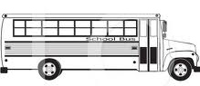



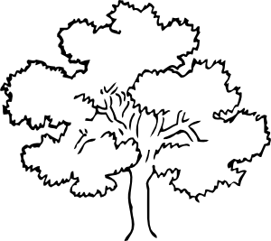













































































































**Visitor**

**PARKING**













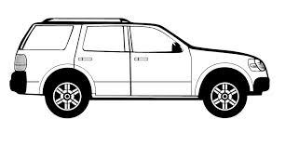





**Teacher & Visitor PARKING**









**\***Wait at the **STOP** sign for a staff member to motion you forward





















**CEDARCREST ROAD**

\***DO NOT Block Cedarcrest Rd.**

**EXIT**

**CARS**

**ENTER**

**CARS**